

**MN507 – Overview of Software Engineering**

**Laboratory 6**: System Modelling 2

**Knowledge Tasks:**

1. Discuss the use of fork and joint in Activity Diagram.

Ans:

Activity diagram represents the series of work and actions in system which is similar to a flowchart or DFD (data flow diagram).

Basic activity diagram notation and symbols:

1. Initial state
2. Activity or action state
3. Action flow
4. Object flow
5. Decision and branching
6. Guard
7. Synchronization
8. Time event
9. Merge event
10. **Fork Node**
11. **Join Node**
12. Final node

**Fork Node**

It has one incoming node and multiple outgoing node. That means splitting incoming flow into multiple concurrent flows. It supports parallelism in activities of a system.

Notation:

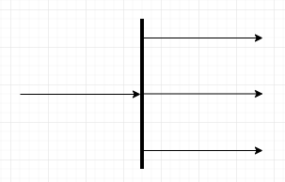

Fig1: fork notation

USES:

To combine two concurrent activities and re-introduce them to a flow where only one activity occurs at a time.

**Join Node**

It has multiple incoming nodes and one outgoing nodes. It also introduces to support parallelism in activities.

Notation:

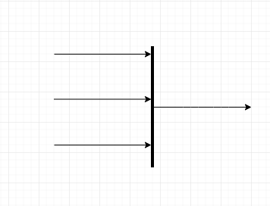

Fig2: join notation

USES:

To split a single activity flow into two concurrent activities.

**Practical Tasks:**

**You are to draw an Activity Diagram for the selected software system.**

1. Draw an activity diagram for the following scenario.

**Develop a software system for a client**

Hint: The steps involved are:

* + Project Manager (PM) first gathers the requirements
  + UI Engineer (UIE) develops the prototype
  + PM shows the prototype to client
  + Till the client is satisfied, UIE modifies the prototype.
  + Client signs off the prototype
  + Once the client is satisfied, UIE develop the UI screens, Software Engineer (SE) develops the system.
  + Once both (system and UI development) are done, SE integrates the system. ● PM delivers the system to client ● Client signs off the delivery.

**Activity diagram:**

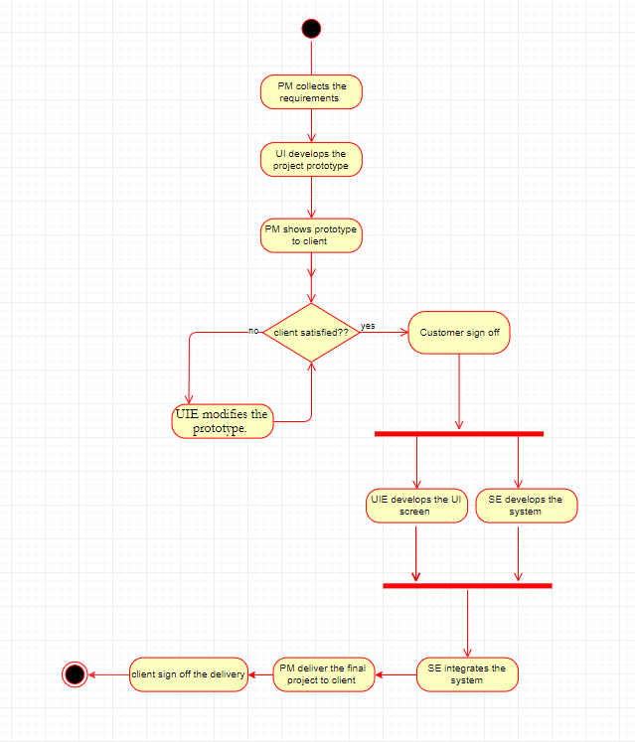

1. Add swim lanes to the Activity Diagram drawn on above activity.
2. Upload your work into your Github and submit the screenshot in the Moodle as well as your work.